**School Supply List 2024-25**

Kindergarten

Grade 1 English & Grade 1 French Immersion

Your classroom teacher will be purchasing most of your child’s supplies that they will need for the school year. This fee will cover items that will be used in the classroom, as well as other educational purposes. The fee this year will be $55.00. This can be paid through School Cash Online (Payments can be made starting August 26, 2024).

You will need to purchase the following items:

* Large Book Bag
* Indoor Sneakers with Velcro fasteners (no black soles, no crocs, no flip flops, or no sandals please)
* Lunch Box
* One box of Large Ziploc bags and one box of sandwich size Ziploc bags
* 2 boxes of Kleenex
* A full change of clothes clearly labeled in a bag with your child’s name on it that will remain at school in case of a need for a change of clothes.

**FHES Family Meet and Greet Fall 2024**

Families are invited to our Meet and Greet on **Wednesday, August 28th at 6:15pm-7:00pm**. We will gather by grade level- Kindergarten, Grade 1, and Grade 1 French Immersion. You will get to meet the teachers and learn about your child’s year to come. You then will have an opportunity to walk around and tour the school.

*Have a wonderful summer and we look forward to seeing you in August/September!*

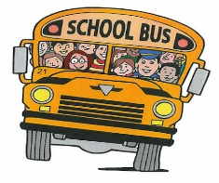-----------------------------------------------------------------------------------------------------------------------

Please return this paper with your child on the first day of school.

Child’s Name: ___________________________________

Where does your child go afterschool?)______________________________________________

Pick Up: (name of person picking up child) ___________________________________________

Bus #:______________

Phone number of where you can be reached if we have any questions: ___________________